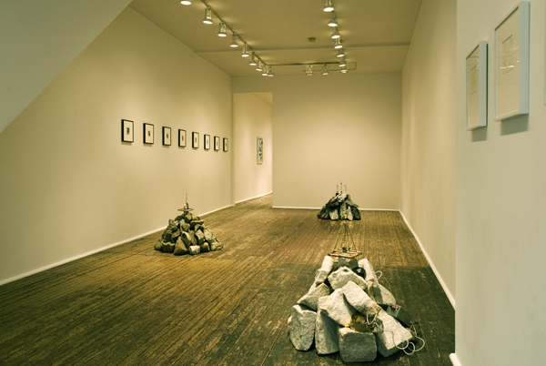

Art: Radio Rocks
June 11, 2008
By: R.B. Strauss
rstrauss@aroundphilly.com

Radio Rocks finds the inimitable Dove Bradshaw back
at Larry Becker Contemporary Art. Now don’t be
mistaken, this exhibition has got nothing to with The Boss,
and everything to do with the Music of the Spheres. The
main component here is three stone cairns that hark back
to ancient burial sites yet they feature manmade receivers
amidst natural elements that scan the ether and play back
what is pulled into their audio orbit. There are also
sketches detailing the work in delicate compositions as
well as a number of pieces that go beyond the
improvisational and on into the realm of aleatory, no
matter that it is visual.

Visit Larry Becker Contemporary Art » Go to Larry Becker Contemporary Art

